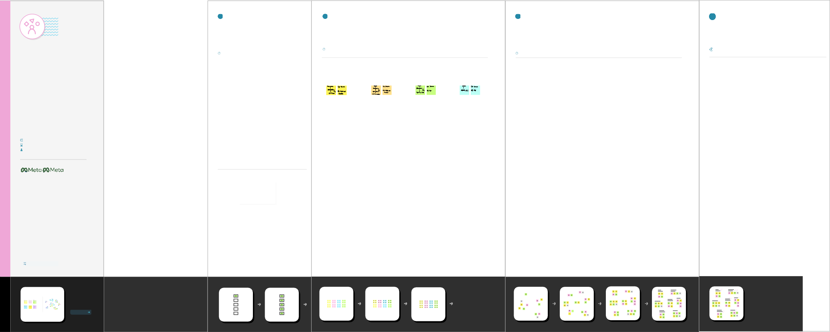

# Brainstrom & idea

## Before you collaborate

A little bit of preparation goes a long way with this session. Here’s what you need to do to get going.

**15 minutes**

**1**

## Problem statement

The food production and its safety are a major problem in agricultural sector. A lot of crops easily gets damaged causing a huge amount of financial loss of nation and even for the farmers (small scale or at large scale). Hence, we developed a stick that will solve all these problems in a better way. This stick will perform all the activities that will help our farmers inmany different ways and will pave a way for Smart Farming into the nation. This stick will provide live data of various different parameters live temperature, soil moisture, humidity, rainfall updates etc.,

**2**

## Brainstorm

Write down any ideas that come to mind that address your problem statement.

**10 minutes**

**3**

## Group ideas

Have everyone move their ideas into the "group sharing space" within the template and have the team silently read through them. As a team, sort and group them by thematic topics or similarities. Discuss and answer any questions that arise. Encourage "Yes, and…" and build on the ideas of other people along the way.

**15 minutes**

**4**

**Prioritize**

### Your team should all be on the same page about what's important moving forward. Place ideas on this grid to determine which ideas are important and feasible.

**5 minutes**

# prioritize

### Executing a brainstorm isn't unique, holding a productive brainstorm is. Great brainstorms are ones that set the stage for fresh and generative thinking through simple guidelines and an open and collaborative environment. Use this when you're just kicking-off a new project and want to hit the ground running with big ideas that will move your team forward.

**15 minutes** to prepare

**30-60 minutes** to collaborate

**3-8 people** recommended

1. **Team gathering**

Define who should participate in this session and send an invite. Share relevant information or pre-work ahead.

1. **Set the goal**

Think about the problem you'll be focusing on solving in the brainstorming session.

1. **Learn how to use the facilitation tools**

Use the facilitation superpowers to run a happy and productive session.

[**Open the website**](https://www.facebook.com/business/m/thinkkit/?ref-northstar)

that will help farmers in deciding the right time for their farming.

Following are certain additional features that is added to our stick:

1. Crop Water Management.
2. Precision Agriculture.

In order to perform agriculture activities in efficient manner, adequate water is essential. Agriculture IoT is integrated with Web Map Service (WMS) and Sensor Observation Service (SOS) to ensure proper water management for irrigation and in turn reduces water wastage.

High accuracy is required in terms of weather information which reduces the chances of crop damage. Agriculture IoT ensures timely delivery of real time data in terms of weather forecasting, quality of soil, cost of labour and much more to farmers.Agriculture IoT systems assures farmers with accurate environmental data via proper live data monitoring of temperature, moisture, plant growth and level of pests so that proper care can be taken during production.

**Sara**

**Tamil**

**Sneha**

**Sivasakarasan**

**Template**

[Created in partnership with](https://about.facebook.com/)

**PROBLEM**

An identified method for smart agriculture system

[**Share template feedback**](https://muralco.typeform.com/to/CiqaHVat?typeform-source=app.mural.co)

**Need some inspiration?**

See a finished version of this template to kickstart your work.

[**Open example**](https://app.mural.co/template/d42717ab-e2ce-4ebc-a805-b0cccd51479d/0436e888-3331-42fe-8cc7-5028b525622e)